Your book project in March is a Book Collage. It is due anytime in March. You can also extend this to the Easter Long Weekend if you need additional time.
Steps for your Book Collage:

- Select a book you have read or are reading in the month of March.
- Grab your scissors, some glue, an old magazine and a piece of paper, cardboard or construction paper.
- Cut out words and pictures that tell something about, or remind you of, the book you have read.
- Glue your words and pictures on your paper in a way that looks “eye catching”. How will you organize them on your paper? Will they be spaced? Will they overlap?
- Your words and pictures should be related to the characters, events, setting, and/or information in your book.
- Include the title and author of your story in some way so we know what book your collage is about.
- Be prepared to tell us why you selected the words or pictures in your collage.
- Have fun and be creative!
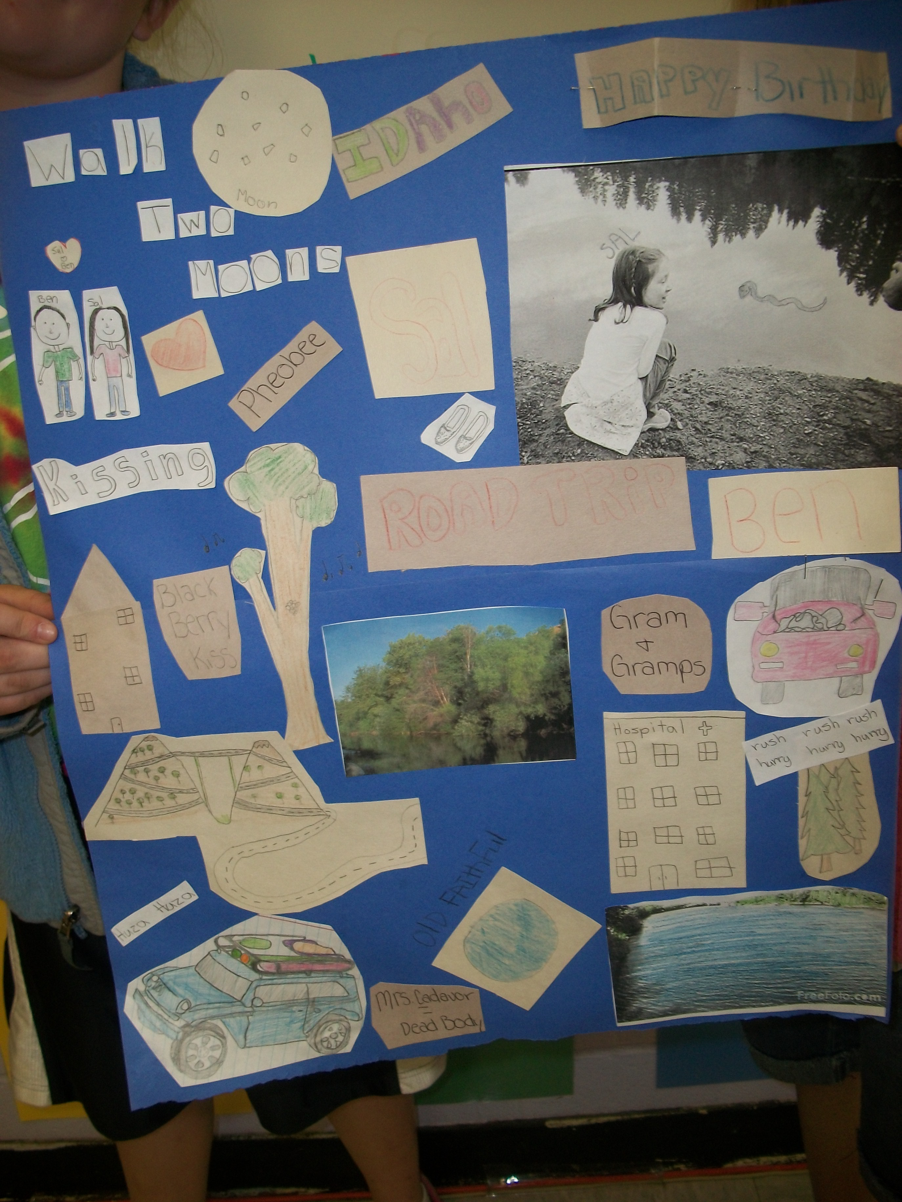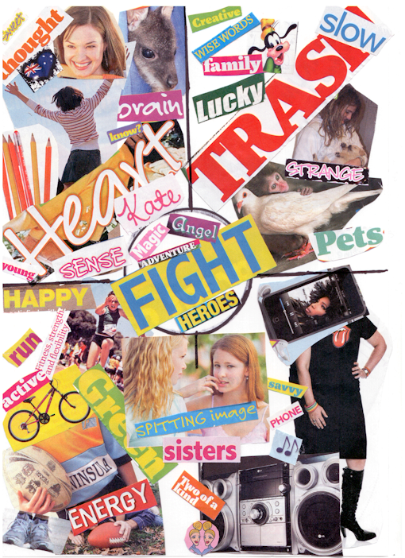
A Book Collage tells about your book
in words and pictures.

