Home Learning May 25 - 29
Sight words for the week:
City, community, countries, exciting, getting, pretty and prettier

Read for 20 minutes and play outside or be active daily
Grade 4 students - I will be adding division lessons to Dreambox this week, so please spend some time on Dreambox this week.

Language Arts Math
Monday | Words of the week  With play - doh, Moon Dough, LEGO or something else you may have at home make your words of the week.  Extension:  Write a sentence with each of the words this week, or try to write one sentence using all the words, this might be tricky. | We are going to be starting division this week, so please watch the videos I post to help you. We are going to take this slow over the next little bit as I know this is brand new for some of you.  1) Watch the video I will be posting about solving division problems using arrays and base 10 blocks.  Answer the following questions using either an array or base 10 strategy.  2) 30 $÷$ 6 =  3) 35 $÷$ 5 =  4) 21 $÷$ 3 =
Tuesday | Last week, you were to write an opinion piece of writing where you share your opinion about something giving reasons and examples as to why that is your opinion.  Today, you will complete the opinion piece by writing a conclusion: https://www.youtube.com/watch?v=3Xo9C8BxgWE&feature=emb_rel_pause  Watch the link above and write your conclusion if you haven’t already done so. Watching the video may be a good idea even if you have finished your conclusion, you may want to go back and revise your conclusion. | Solve the following problems using the array strategy.  1) There are 12 drum dancers. They will dance onto the stage in equal rows. How many dancers could be in each row? Use arrays to show the possibilities.  2) There are 28 students in a class. The teacher needs to put them in equal groups for an activity. How many ways can she group the students. Use arrays to help you show the possibilities.
Wednesday | Today I want you to watch the video below about revising, which makes our writing better.  https://www.youtube.com/watch?v=6sZao2fUhSw  I will also be posting a video of my writing which I have revised.  After watching the two videos, I want you to revise your writing. | Dreambox to practice the division lessons.
Thursday | Today, please watch the following video on editing to fix mistakes in spelling, capitalization and punctuation: https://www.youtube.com/watch?v=LSmjkSkaR70  After watching the video, please edit your writing.  You have just finished your first opinion writing! I’m very proud of your hard work. I’d love to see or hear your writing if you want to send me a picture or video. | Today you will be learning about remainders. I have posted a video that you will need to watch before you solve the following problems. Make sure you show all of your work for each question.  1) Caleb is putting his markers into packages. He has 43 markers. Each package holds 8 markers.  a) How many packages will Caleb fill?  b) How many markers will he have left over?  2) 24 $÷$ 3=  3) 20 $÷$ 6  4) Elizabeth takes 2 apples to school each day as a snack. She has 15 apples. How many days can Elizabeth take her snack to school?
Friday | After you finish reading today, record three unfamiliar words that you came across while reading. What did you think each word meant? Why? | Division War  Players – 2 and up  Card Values - Ace represents the number “1,” Jack is “12,” Queen is “14,” King is “15,” Joker is “16”. Other cards stand for their face values  Objective – win the largest number of cards  Preparation – deal all the cards to the players, they form a stack with the cards facing down.  How to play - On a “ready, set, go!” count, each player turns over two cards (with 2 or 3 players) or one card (4 or more players). The first player who identifies a division fact with the cards on the table can take all the cards and put them under their stack of cards. A division fact is a set of three cards that form a division equation. For instance, a player sees a 10, 5 and a 2 and says: “10 divided by 5 equals 2!”. If no player identifies a division, all players turn over new cards.  End of game - The game is finished once one of the players does not have any cards left. The player with the largest number of cards wins; this can take quite a long time with two players, so in this case, you might prefer not to enable players to reuse already won cards.

Challenge for the Week: Please note this is completely optional and if you and your child choose to attempt this please do not go out and buy anything you. Use items around your home or have the students use their imagination and improvise.
THE CHALLENGE: A habitat is the natural home or environment of an animal, plant, or other organism. Deserts, oceans, mountains, and forests are some types of habitats. Many are threatened by climate change and human activity. Your challenge is to measure out 1 square meter of land of your choice and observe the biodiversity you see in just this small chunk of Earth. The lawn, the garden, in the woods, shaded or sun-kissed. Record your findings in your journal.

Language Arts/Social Studies: There are habitats all around us which are part of your physical environment in your local area. Study the photo below and relate it the physical environment in your local area; Miramichi River, Nepisiguit River, Restigouche River, or Kedgwick River.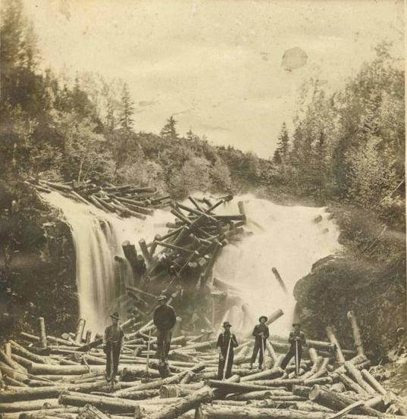

Numeracy: One square meter is the area equal to a square that is 1 meter on each side. Area is the space inside a shape. If you wanted to use rope to make your 1 m² shape, how much rope would you need for the perimeter? Click here to learn more about area perimeter. https://www.youtube.com/watch?v=rSVMrPu0__U

Science:: After you have carefully observed your square meter of habitat, draw a table to organize your observations. How many different species of living things did you see? How many of each? What did they look like? (write or draw what you observed) What was their habitat like? Be descriptive and use all your senses safely!

The Arts: Edible Art! Put on your chef’s hat and try creating a snack that is ALMOST too beautiful to eat! Bonus points if it’s all healthy! Check out Canada’s food guide here for more information on healthy foods. https://food-guide.canada.ca/en/

