Home Learning May 4-8
Sight words for the week:
le, la, les, quoi, quand, nous, ou, où, vos
**ou-un choix/a choice **où-un lieu/where

Read for 20 minutes and play outside or be active daily

FILA Math
Monday | Est-ce que tu parles en français à la  maison? Est-ce que tu connais une  personne qui parle le français comme toi?  Appelle un ami(e), un membre de ta  famille ou un voisin qui parle en français.  Pratique les questions suivantes :  Comment ça va? Quel temps fait-il  aujourd’hui? Qui est dans ta famille? As-tu un animal de compagnie? Quel est ton  passe-temps préféré?  Extension: Write out the answers they give you as if you’re doing an interview. | Equal groups to multiplication sentences  Video #1 and #2  Answer the questions on the attachment titled equal groups to multiplication sentences.  #1a-d and #2 a-d
Tuesday | BINGO Printemps  Print the BINGO game with spring words or make your own. Play the game friends from class to practice or family members. This will help you improve your vocabulary for spring-time words.  Extension: make your own BINGO game with spring words you find in the dictionary or on the internet. Practice playing the game and expanding your vocabulary. | Pratiquer-practice  Trouve le produit de chaque multiplication. Dessine les groupes égaux.  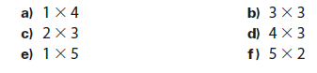  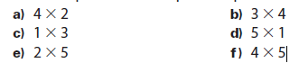  Find each product. Draw equal groups to help.

Wednesday | Une expérience de science – une tornade dans une bouteille  Science experiment – tornado in a bottle  Follow the steps in the document attached to make a tornado in a bottle. After, describe what you saw and what you liked or didn’t like about the experiment.  What did you learn about tornados last week? Are there any similarities between your tornado and a real one? | Mental Math Games  Play a math game of your choice. You can choose a website and find a game or practice a skill.  OR  Practice mental math strategies using one of the games provided.
Thursday | Word work- play a game to practice words of the week.  Fais un poème acrostiche avec les mots de printemps dans ton jeu de BINGO.  F-fantastique  L- l’eau  E-environnement  U-unique  R-rose  OU  Fais un acrostiche avec les qualités de ton ami(e) proche.  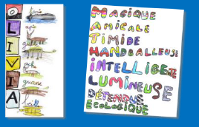 | Problèmes de mots – word problems practice  Print out and use the attached task cards or write them out by hand.  For each card you will need to write the multiplication sentence that goes with it and find the answer. There is a tracking sheet for your answers or you may use loose-leaf.  Answer key is attached to check your answers at the end.  Extension: Write your own word problems for multiplication.  Voici un exemple: Claire fait deux piles de livres. Elle met quatre livres dans chaque pile. Combien de piles Claire prépare-t-elle? Combien de livres y a-t-il dans chaque pile? Combien de livres y a-t-il en tout?

Friday | Time Capsule Activity -Capsule de temps  Complete page 3 of your time capsule “Mes seniments”  **Time capsule document is uploaded on my teacher website. If you are unable to print, you can recopy by hand the page and fill in your information.  Extension: Call a friend or read to a family member and share what you included on page three and why. Parle français mes amis! | Roll and multiply  Find two dice and cover the 6s with a piece of masking tape and write any number 1-5 to replace.  Roll both dice and create a multiplication sentence and then find the answer.  Example: You roll a 2 and a 5.  You would write 2x5=10. Draw equal groups to help you figure it out.  Play with someone else and keep score.  Extension: cover some of the lower numbers with numbers higher than 6.

