November 4th, 2021
Good morning,
Today’s home learning plan is as follows:
Literacy: Read for 20 minutes or go on Epic and listen to some stories
Word Work: practice our words of the week: look, up, had, sad, fox
Example: Try playing a game of tic tac toe using 2 sight words. Take a letter away – ask what letter is missing, rewrite the words with all the letters, mix up the letters – put the letters in order, call out a word and have your child spell it
Writing: Please see the video I posted for your writing assignment today. You will be brainstorming 3-6 ideas for a personal narrative.

Math:
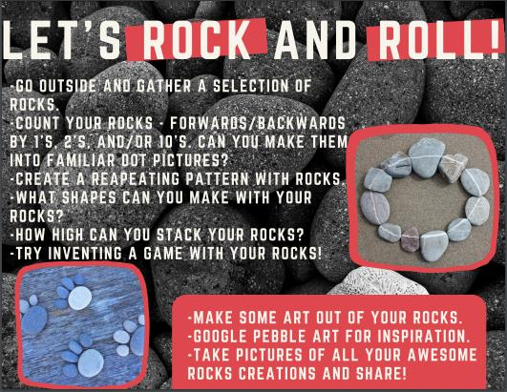

Happy Learning!

