Math Choice Board. Try these activities this week!
Play Fish to get pairs that make 10. Deal each player 5 cards.  Take turns asking for a number that would go with one of the cards in your hand to make a combination of ten. | Count forwards and backwards to and from 100.  Can you do this by 2s? Can you do this by 10s or 5s? | Try breaking up numbers into tens and ones:  Example:  Number of items Tens and ones  42 36 Tens Ones 4 2 3 6 | Write the numbers to 100!
Draw a picture to represent 42 (or any 2-digit number). You could draw:  • base ten blocks  • ten frames  • tallies  • coins  • another picture  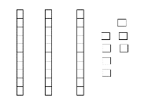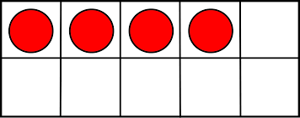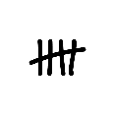 | Go on dreambox for 15 minutes each day. | Create a toothpick design with this number of toothpicks:  • 1 less than 10  • 2 more than 12  • 2 less than 20  • 1 more than 15  • 2 more than 18  Try some others! | 2 4 6 8 10 12  Play “Cover It” by making a  game board like the one above. Roll a dice. Double the number and colour the number on your game board. Want to use numbers to 20? Use a deck of cards and turn over a card and double it using numbers to 20!  2 4 6 8 10  12 14 16 18 20

